PE code Injection

Adding of new section of 6000 bytes to putty

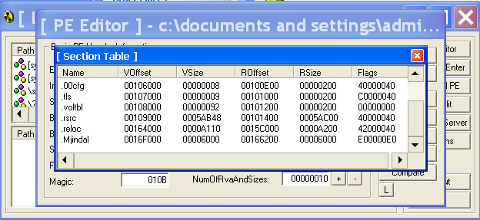

Program get crashed due to header mismatch

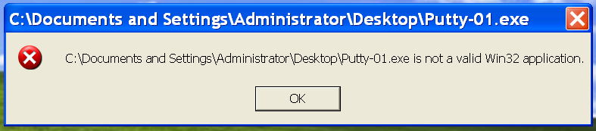

Filling extra 00 bytes equivalent to 6000 bytes to balance header and program size

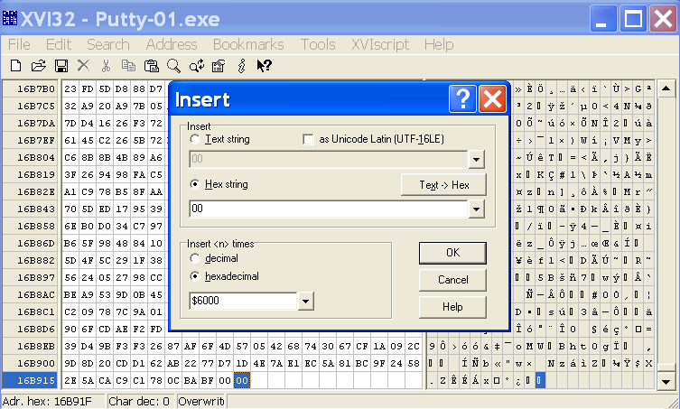

Program runs successfully after that

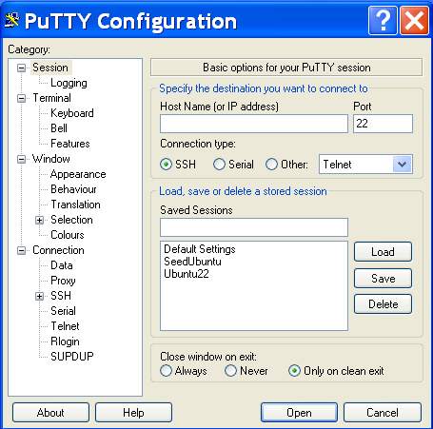

Modifying the entry point of the program



Program crashes

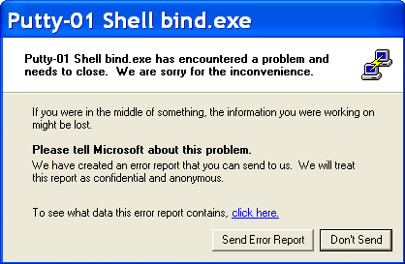

Filling section with NOPs

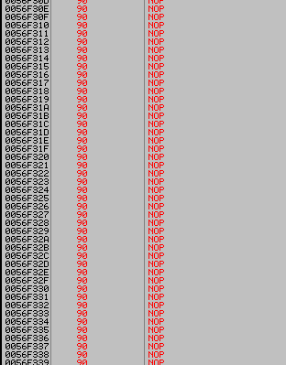

Writing strings for MessageBoxA

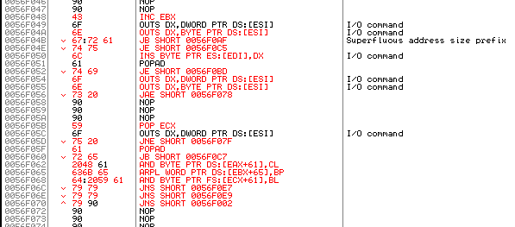

Calling MessageBoxA

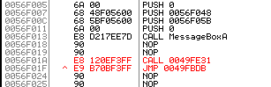

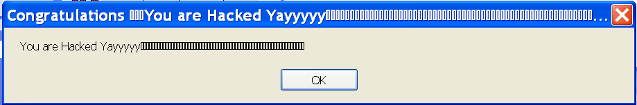

Payload Creation

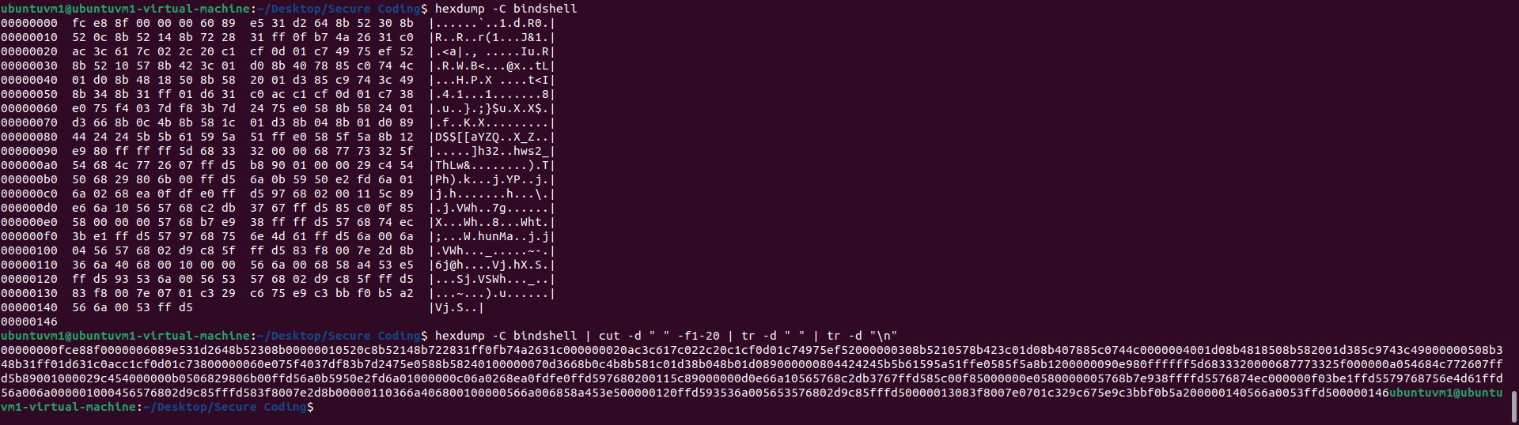

Adding of payload in executable

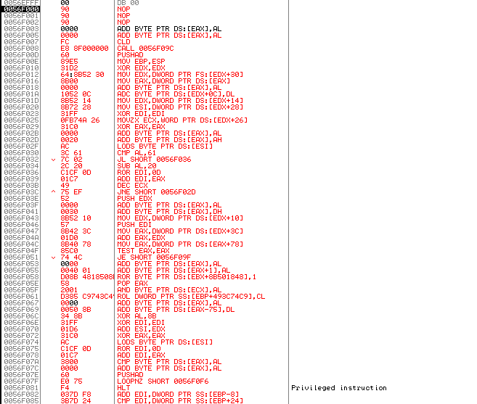

Netstat Command (no 4444 port)

